*Florida International University*

*School of Computing and Information Sciences*

Software Engineering Focus

Interactive Paint

User Story ID <320>

**Name:**

Jim Louro

**Team Member(s):**

Daniel Mederos

**Project:**

Interactive Paint

**Product Owner(s)**:

Francisco Ortega

**Mentor(s)**:

**Instructor**: Masoud Sadjadi

# User Story Name: Implement a line brush to read in mouse movement

* Description: As a developer I want to implement a class that allows the user to free hand draw on the painting application.

Acceptance Criteria

* Must use QT widgets
* Must not depend on other classes only QT so it can be extended to host multiple input items

**Use Case** Create a brush in the GUI Canvas

|  |  |  |
| --- | --- | --- |
| #**325 Make the brush** | | |
| ***Description*** | When the user selects to free draw then brush should read the user input and trace a line to allow free draw | |
| ***Actor*** | User of Interactive Paint | |
| ***Precondition*** | GUI must be running | |
| ***Flow of Events*** | **User** | **System** |
| **1.** | User clicks on Brush button | A dropdown menu appears and the brush button appears |
| **2.** | User clicks on line button | The mouse pointer is now active with the brush function |
| **3.** | User clicks on the GUI Canvas | A dot appears on canvas when canvas receives a click or input and when moved it forms a 2d non linear shape that ends when the click or input stops |

**Use Case Diagram**

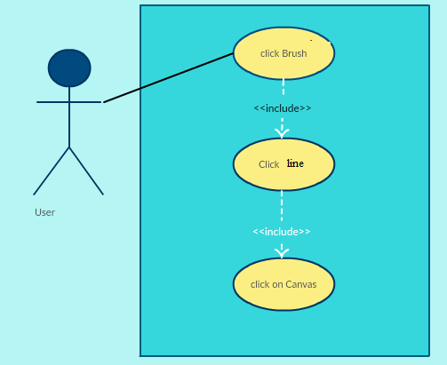

**Sequence Diagram**

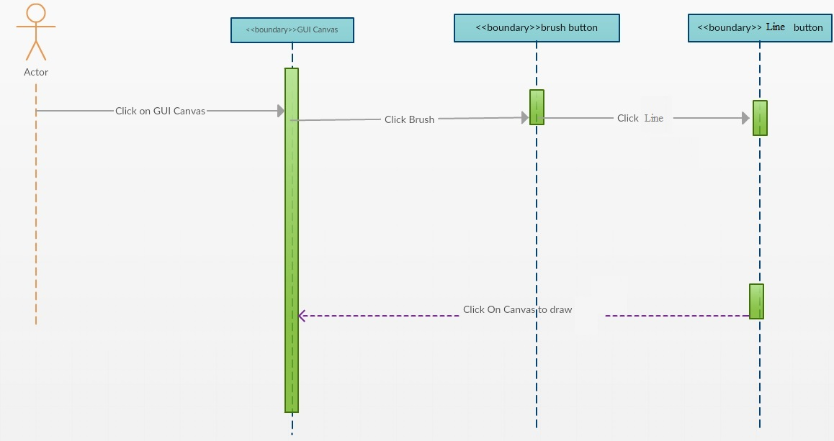

**Class Diagram**

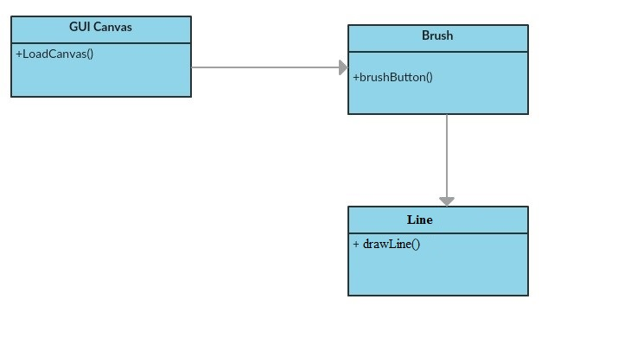

**Integration Test**

**Testing**

**Description:**

* Test the Line button and lets the user draw a Line on the GUI canvas

**Work Log:**

**Unit Test**

**Test Case 1 (sunny)**

***Purpose:*** to test that the line button appears when user clicks on brush button

* Precondition The user must have QT plugin for visual studio and must run the program
* Input: User clicks on brush button which then a drop down menu appears
* Expected Result: line button appears on GUI Canvas from a drop down menu
* Actual Result: Actual result was found to be the expected result.
* Status: **PASSED**

**Test Case 2 (sunny)**

***Purpose:*** to test that the line button properly lets the user draw a line on the GUI Canvas

* Precondition The user must have QT plugin for visual studio and must run the program
* Input: User clicks on brush button which then a drop down menu appears and must click line
* Expected Result: line appears on GUI Canvas when dragged across canvas
* Actual Result: Actual result was found to be the expected result.
* Status: **PASSED**

**Test Case 3 (rainy)**

***Purpose:*** to test that the line button appears when user clicks on brush button

* Precondition The user must have QT plugin for visual studio and must run the program
* Input: User clicks on brush button which then a drop down menu appears
* Expected Result: line button appears on GUI Canvas from a drop down menu
* Actual Result: Actual result was found to be the expected result.
* Status: **PASSED**

